**Question 5: Disney Characters** (5 points)

Program the three buttons in q5disney.html to display each of the three Disney characters along with their name and quote. You are to pull this through an Ajax call from: [http://ict.neit.edu/evanrense/disney/disney.php.](http://ict.neit.edu/evanrense/disney/disney.php)

Note that you can pass in different character numbers to this page: <http://ict.neit.edu/evanrense/disney/disney.php?character=1>etc.

See q5disney.mp4 for a 3 second video of the desired behavior.

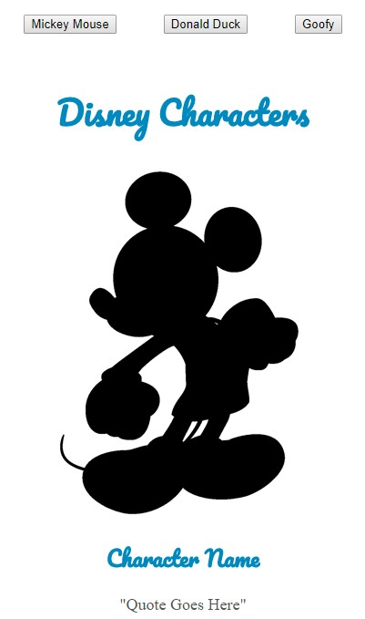

* .5 point for retrieving and console.log() data.
* .25 points for each button that is clickable   
  *(event if they simply console.log or alert)*
* .25 points per button for changing the quote when the corresponding button is clicked.
* .25 points per button for changing the character name when the corresponding button is clicked.
* .25 points per button changing the image when the corresponding button is clicked.
* .25 points for each button that works as demonstrated in the video
* .75 points for using the retrieved data to complete this program

**Final**

**Practical Exam**

**Instructions:** Choose one of the following projects to complete in class. The files must be submitted via a URL and a zip file to the program that you completed.

**Car going around and around** (5 points)

Note the car track in q4car.html. The start button simply starts the movement of the car around the canvas. Upon clicking the Start button, the caption changes to “Stop” and when clicking the stop button, the car stops and the caption changes back to “Start.” See q4car.mp4 for a 10 second video of the desired behavior.

